User Guide – Milestone 4

Team: charlie

Presented by: Michael Le, Debashis Jena, Austin Johnson, Prince Antwi Aboagye, Didimus Kimbi, Damion Sevilla

SWEN 670 – sOFTWARE eNGINEERING pROJECT

Project name: Mnemosyne, Disability Mobile Application

Date: August 06, 2021

Project Leader: Michael Le

Phase: Design & Engineering and Execution

For approval: Michael Le

Michael le Date: 08/06/2021

For approval: Dr. Mir Mohammed Assadullah

Date: 08/06/2021

Revision History

|  |  |  |  |
| --- | --- | --- | --- |
| Version Number | Date | Description | Approved By |
| 1.0 | 08/06/2021 | Initial User Guide Release | Michael Le |
|  |  |  |  |
|  |  |  |  |

Table of Contents

1. Introduction 5

1.1 Purpose 5

1.2 Overview 5

1.3 Definitions, Acronyms, and Abbreviations 5

1.4 Reference 6

2. Software Description 7

2.1 Features 7

2.1.1 Easy Navigation 7

2.1.2 Android and IOS Devices Support 7

2.1.3 Usability/Learnability 7

2.1.4 Portability 8

3. Connection to the application 9

4. Software Specifications 10

5. Hardware Specifications 11

6. App Page 12

6.1 Permission Required Page 12

6.2 Restart Application 17

6.3 Homepage/Set up Voice Profile 18

6.3.1 Recording Page (Conversation) 21

6.4 Drop-down Menu 23

6.5 New Notes Page 25

6.6 Edit Note Page 28

6.7 View Note Page 30

6.7.1 Display All Notes under a specific date. 31

6.7.2 Search Note via a text field 32

6.7.3 Search Note via Voice Command 34

6.8 Personal/Favorite Page 36

6.9 Settings Page 44

6.9.1 Adjusting Text Size 45

6.9.2 Adjusting Days until Auto Delete 46

6.9.3 Training Video 47

6.9.4 Re-record Voice Profiles 48

6.9.5 Reset Settings 48

6.9.6 Delete All Notes 48

6.10 Notifications 48

6.10.1 Slide to View Notification 49

6.10.2 Click to View Notification Message 50

7. Troubleshooting 51

7.1 Issue installing Flutter on MacOS 51

7.2 Emulator does not respond or slow 51

7.3 Unable to launch Emulator from Editor 53

7.4 Slow Running the App (Stuck at Running Gradle task 'assembleDebug') 53

7.5 Dependency Issues 54

7.6 Miscellaneous 54

# 1. Introduction

## 1.1 Purpose

This user guide document aims to illustrate and demonstrate the guidance of the Mnemosyne mobile application. It will assist users in navigating things such as application features functionalities, troubleshooting, system connection, and software specification.

## 1.2 Overview

The Mnemosyne mobile application will show all the functionalities base on the requirement list. The significant functionalities include record speech, record speech of the user only, voice recognition training, save and retain text, search text, visual options, training videos, and notification to user. Once the application development is complete, it will hand over to a DevSecOps team, and further action to deploy to iOS and GooglePlay will be up to their team to take action. This User Guide will be available online for deployment as well to help further guidance on the application.

## 1.3 Definitions, Acronyms, and Abbreviations

Table 1 - Definitions, Acronyms, and Abbreviations

|  |  |
| --- | --- |
| Acronyms and Abbreviations | Definitions |
| AVD | Android Virtual Device |
| APK | Android Application Package |
| AMD | Advanced Micro Devices |
| iOS | iPhone operating system |
| RAM | Random Access Memory |
| Flutter CLI | Flutter Command Line Tool |
| CPU | Central Processing Units |
| IT | Information Technology |
| IDE | Integrated Development Environment |
| SDK | Software Development Kit |

## 1.4 Reference

Apple Inc. (2020, October 22). *Use touch id on iphone and ipad*. Apple Support. <https://support.apple.com/en-us/HT201371#:~:text=Go%20to%20Settings%20%3E%20Touch%20ID%20%26%20Passcode,the%20list%20by%20touching%20the%20Home%20button%20>.

Verizon. (2021). *Add Additional Fingerprints - Samsung Galaxy S6 edge +*. Verizon. https://www.verizon.com/support/knowledge-base-211823/#:~:text=From%20the%20%22Register%20fingerprint%22%20screen%2C%20follow%20on-screen%20instructions,registered%20fingerprint.%20Tap%20%2B%20%28located%20in%20the%20upper-right%29.

# 2. Software Description

Charlie Team developed the Mnemosyne short memory assistance mobile application to recognize and save users' speech as they engage in conversation. The purpose is to help people with short-term memory disabilities live a fuller life despite their disability, enabling users to remember meaningful conversations and ideas. There is a facility in the app to allow the user to train the app on its voice/key phrases, and by so, the application should recognize distinct phrases and sentences of the user.  The application tune into ignoring everything except the user speaks, covering the speech to text, which shall save for a maximum of 1 week. Users can always retrieve notes via a search command. Training videos are provided within the app to guide the user regarding its various features and functionalities.

## 2.1 Features

### 2.1.1 Easy Navigation

More straightforward the design of the app, the more accessible it is for users to navigate. The interface of the Mnemosyne app is organized and has easy-to-understand navigation, which helps enhance the user experience.

### 2.1.2 Android and IOS Devices Support

One best way to get customer's attention is to provide a mobile app compatible on multiple or many platforms. This feature will provide users with options on when and how to access the Mnemosyne app.

### 2.1.3 Usability/Learnability

The effort and time required to learn the Mnemosyne software are minor, making it user-friendly for everyone.

### 2.1.4 Portability

Mnemosyne apps can perform the same functions across all environments and platforms (iOS and Android).

# 3. Connection to the application

The Mnemosyne mobile application is a standalone application, which does not require any user credentials to use it. The application has been made compatible with iOS devices as well. So, users will use an actual iOS device or an XCode Simulator to test or use the application. As the application build file (APK) is available, users can drag and drop in the Android emulators or real devices to test or use.

(Warning: This paragraph only refers to whoever concern with the application. Users should not have to worry about application since it only downloads and ready to use after deployment to the App Store finished). The developers can refer to the Programmer Guide and Deployments Operation Runbook to download the necessary software and hardware system. In addition, the app will be available on Android, Google Play, and Apple Store for the user to download. This deployment is dependent on Dr. Assadullah at [mir.assadullah@faculty.umgc.edu](mailto:mir.assadullah@faculty.umgc.edu) to make execution in the future.

# 4. Software Specifications

The Mnemosyne mobile application uses the following software:

* Flutter Platform
* Dart Programming Language – SDK version 29
* Google Cloud Platform's Speech-to-Text Service
* Git for Version Control System
* Development tools
  + VS Code / IntelliJ IDE
  + Android Studio for Emulator
  + XCode for iOS Simulator

# 

# 5. Hardware Specifications

The Mnemosyne mobile application requires the following hardware systems with the specifications:

* Flutter System Requirements:
* Operating Systems: Windows 7 SP1 or later (64-bit), x86-64 based.
* Disk Space: 1.64 GB (Does not include disk space for IDE/tools).
* Tools: Flutter depends on these tools being available in your environment.
* Windows PowerShell 5.0 or newer. (Pre-installed with Windows 10)
* Git for Windows 2.x with the Use Git from the Windows Command Prompt option.
* Android Studio System Requirements:
* 64-bit Microsoft Windows 8/10
* x86_64 CPU architecture; 2nd generation Intel Core or newer, or AMD CPU with support for a Windows Hypervisor
* 8GB RAM or more
* 8GB of available disk space minimum (IDE + Android SDK + Android Emulator)
* 1280 x 800 minimum screen resolution

# 6. App Page

## 6.1 Permission Required Page

The permission required page is the first page that displays when you open the Mnemosyne app. This page asks for permission to access the device's Microphone, Photos, and Media.

**Figure 1: Permission Required Page**

To allow access to the Microphone, you will have to click on Microphone (displayed in figure 1)**.** The system shall ask you, "Allow Mnemosyne to record audio?". You may choose the "While using the app" or "Only this time" option to allow Mnemosyne to record audio (displayed in figure 2).

**Figure 2: Record Audio**

After choosing either "While using the app" or "Only this time," the system displays "Microphone Granted." It is shown in figure 3.

**Figure 3: Microphone Granted**

To allow access to Photos and Media, you will have to click on Photos and Media (displayed in figure 4)**.** The system shall ask you, "Allow Mnemosyne to access photos and media on your device." You may choose "Allow" to grant Mnemosyne access to photos and media on your device (displayed in figure 4).

**Figure 4: Display Allow and Deny**

After choosing "Allow," the system displays "Photos and Media Granted." It shows in figure 5.

**Figure 5: Display Continue Button**

Now that both Microphone, Photos, and Media access grant, you will have to click on the "Continue" button (displayed in figure 5) to move to the next page.

## 6.2 Restart Application

You will have to restart the app to get the Microphone activated and the Mnemosyne app to record audio. Figure 6 displays instructions to restart the app to get the Microphone activated.

**Figure 6: Restart App**

## 6.3 Homepage/Set up Voice Profile

The homepage/Set up voice profile is the page that displays after restarting the Mnemosyne app. This page is where the Mnemosyne app learns the user's voice by recording the voice profile. You may train the app on your voice on this page. The page (figure 7) displays the microphone icon and instructions on recording your first speech.

**Figure 7: Display Microphone Icon and Instruction**

To record your voice profile, you will have to tap on the microphone icon, speak for a couple of seconds and let the Mnemosyne app recognize your voice. In figure 8, the microphone icon click and recording are in process.

**Figure 8: Microphone Icon Clicked**

You may stop recording by tapping on the microphone icon. The system shall display (figure 9), "How does it sound?" play icon, the message (Meeting at 6), "retry," and "continue."

The play button replays the message back to you. If you click on "retry," the system will abort the process and prompt you to record a new voice profile. If you are satisfied with the message displayed, you may click "Continue" to start a conversation on the recording page (figure 10).

**Figure 9: System Display Instruction**

### 6.3.1 Recording Page (Conversation)

The Recording Page (figure 10) is where your speech converts to text during the conversation with other people. On this page, the Mnemosyne app recognizes your voice and converts your speech to text, and also sets the voice profile at the top.

**Figure 10: Recording Page**

Demo – The App sets the voice profile at the top as speech convert into text.

Before engaging in conversation, you will have to click on the microphone icon. In figure 11, the app recognizes the user's voice during the conversation and sets the voice profile on top as the user's speech converts into text, "I will have a meeting with you at the restaurant 2".

The user stops recording by tapping on the microphone icon. The system saves the notes along with the date and time.

**Figure 11: User Voice Record**

## 6.4 Drop-down Menu

When you click on the menu icon on the top right corner, the system shall display a drop-down of "New Note," "View Note," "Personal/Favorites," "Settings," "New Recordings," and "Back" button. You may exit the menu drop-down by clicking on the "Back" button.

**Figure 12: Drop Down Menu**

**Recording Page (Conversation)**

You may begin a new recording by clicking on the "New Recording" feature on the menu drop-down.

Figure 13 displays after clicking on "New Recording."

**Figure 13: New Recording**

## 6.5 New Notes Page

The new note page allows you to create new notes and save them to storage. To access the new notes page, you will click on the "New Note" feature on the drop-down menu. The new note page (figure 14) displays a text field and a "Save" button. To create a new note, you will have to enter data into the text field and click save.

**Figure 14: Displays Text Field**

In figure 15, the user enters data "football matches" into the text field and clicks on the "Save" button.

**Figure 15: Enter Data**

In figure 16, the system saves the notes along with the date and time create. By clicking on the "Back" button, the system redirects you to the "View Note" page or search screen.

**Figure 16: System Save Notes**

The additional features at the bottom of the screen in figure 16 describe below:

The speaker icon allows you to play the notes loud

The heart icon will enable you to select the notes as your favorite

The "+" icon allows you to create a new note

The delete icon allows you to delete notes.

The edit icon allows you to add or modify a note

## 6.6 Edit Note Page

The "Edit" icon allows you to add additional information to notes already saved in the storage. The Edit icon, when clicked, displays the page (figure 17) below. You may choose to modify the information in the text box and save the newly added information or keep the current information "football match" by clicking on the "Cancel" button to abort the process.

**Figure 17 Edit Note Page**

**Choose Note as Favorite**

As described earlier, clicking on the favorite (heart) icon allows you to select the note as favorite. In figure 18, the note "football match" select as favorites. You may notice that the heart icon fills the note select anytime as favorite. The favorite icon is displayed beside the note anytime that is selected for view.

**Figure 18: Favorite**

Click the "Back" button to redirect you to the "View Note" page.

## 6.7 View Note Page

The "View Note" page displays the search bar, "+" icon, and the dates of notes created.

**Figure 19: View Note Page**

### 6.7.1 Display All Notes under a specific date.

In the scenario above (figure 29), there is only one date recorded for all notes. You may view the notes under the date August 5, 2021, by clicking on the date. After clicking on the date, the system shall display all notes under the chosen date (Figure 20).

**Figure 20: Option Chosen date**

Note: Notes display along with the time recorded and other attributes (favorite).

### 6.7.2 Search Note via a text field

You may search for notes via the text field. To search for notes, you have to enter data into the text field and click enter. In figure 21, the user enters the data "football match" and clicks enter. The system responds by displaying the date the note was created.

**Figure 21: Enter Data**

You may proceed by clicking on the date to view the "football match" note along with the recorded time. If the user's note mark as favorite, the system will display the favorite icon beside it. To clear search and enter new data, you must click on the "X" sign in the search bar. Also, you may click the "Back" button to start a new search (display in figure 22).

**Figure 22: New Search**

Note: The + icon allows you to create a new note

### 6.7.3 Search Note via Voice Command

Also, you may search for notes via voice command. To search for notes, you will have to click on the microphone icon. The system shall ask, "Allow Gboard to record audio?" (displayed in figure 23). Choosing one of "While using the app" or "Only this time" will grant access to the Gboard to record audio.

**Figure 23: Voice Command**

You may click on the Microphone icon to begin recording once the "Speak Now" text is displayed (figure 24). If the Microphone captures the specified phrase and is satisfied with the displayed note, you can click enter. To view the note, you will have to click on the displayed date. If the user's note mark as favorite, the system will display the favorite icon beside it. To clear search data and start a new voice search, you will click on the "X" sign in the search bar. Also, you may click on the "Back" button to start a new search.

**Figure 24: Display Text**

Note: You may access a favorite note by following steps under the Personal/Favorite page.

## 6.8 Personal/Favorite Page

The personal/favorite page allows you to view all personal or favorite notes. In the scenario under the favorite icon feature (figure 18), we selected the note "football match as favorite.

This page requires fingerprint authentication to access favorite notes. You need to register your fingerprint on the device.

The system shall prevent you from accessing favorites if no fingerprint or face id set up on the device. Figure 25 displays the error message.

**Figure 25: Error Message**

**Steps to register fingerprints on Android device**

1. Open Settings on your device
2. Scroll down to locate Security. Click on Lock screen security
3. Tap Fingerprints
4. If prompted, enter your password, then tap NEXT
5. From the "Register fingerprint" screen, follow on-screen instructions to register
6. To register additional fingerprints:
7. Tap + Add fingerprint
8. Swipe the registered fingerprint
9. Tap + (located in the upper-right)
10. Repeat steps 1 and 2

(Verizon, 2021).

**Steps to register fingerprints on iOS device/Set up a Touch ID**

"Before you can set up Touch ID, you need to [create a passcode](https://support.apple.com/kb/HT204060) for your device. Then follow these steps:

1. "Make sure that the Touch ID sensor and your finger are clean and dry."
2. “Tap Settings> Touch ID & Passcode, then enter passcode”.
3. To Add a Fingerprint and hold your device as you normally would when touching the Touch ID sensor
4. Touch the Touch ID sensor with your finger- but don't press. Hold it there until you feel a quick vibration or ask to lift your finger.

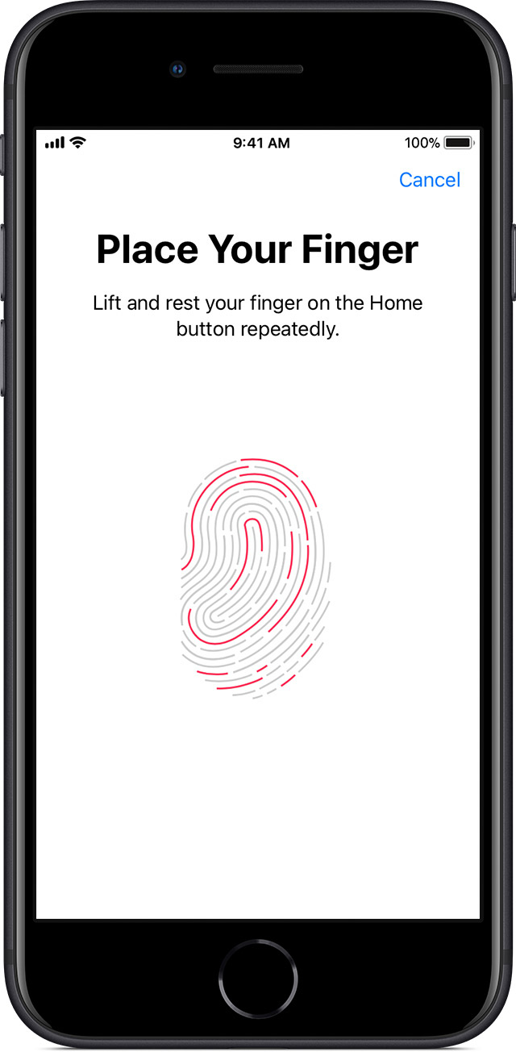

1. Continue to lift and rest your finger slowly, making minor adjustments to the position of your finger each time.
2. The next screen asks you to adjust your grip. Hold your device as you normally would when unlocking it, and touch the Touch ID sensor with the outer areas of your fingertip instead of the center portion that you scanned first (Apple Inc, 2020).

If you have trouble enrolling one finger, try another" (Apple Inc, 2020).

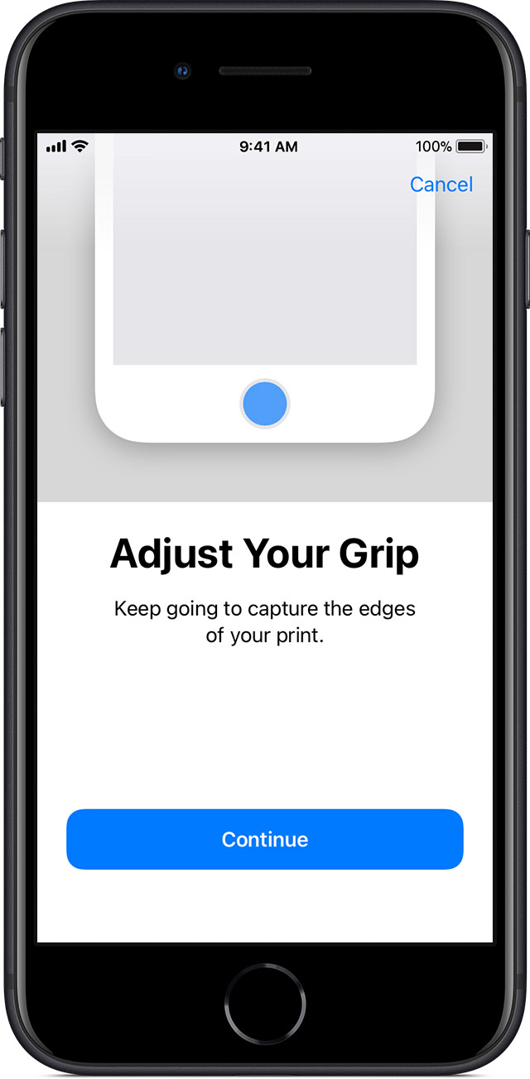

(Apple Inc., 2021)

If your fingerprint successfully registers on the device. By clicking on the Personal/Favorites feature, the system shall display the fingerprint "Authentication required" screen (figure 26)

**Figure 26: Authentication Require**

Note: You have to "touch the fingerprint sensor" with the registered finger when this screen appears. If the right finger is used, the system shall detect the registered, and all notes mark as favorites along with the date recorded will display (figure 27).

**Figure 27: Displayed Record Date**

You may choose a date to view all notes marked as favorites along with the time recorded (displayed in figure 28).

**Figure 28: Displayed Favorites**

When you select the favorite note (in our case, we will choose a football match note) to view. The system again displays the fingerprint "Authentication required" screen. If the system detects the registered finger, the "football match" note will display along with the property icons at the bottom of the screen (figure 29). You may choose to remove it as the favorite by clicking on the favorite icon.

**Figure 29: Remove Favorites**

## 6.9 Settings Page

You may access the settings page by clicking on "Settings" on the drop-down menu.

The settings page (figure 30) displays Text size alignment, Days until auto delete (notes), Training Video, Re-record voice profile, Reset Settings, and Delete All Note feature.

**Figure 30: Setting Page**

### 6.9.1 Adjusting Text Size

To maximize the sizes or font of the texts, you will have to drag the line forward, while to decrease the sizes of the text, you have to drag the line backward. The system displays font numbers while you are dragging the line. Figure 31 displays text size maximized.

**Figure 31: Adjusting Text Size**

### 6.9.2 Adjusting Days until Auto Delete

This feature allows you to control the number of days notes should be kept in the storage. Dragging the line forward increases the days until auto delete, whiles dragging the backward line decreases the number of days the note should last in the storage. The system displays the number of days to make it easy for users to set the specified number of days in dragging the line. Figure 32 shows increase days until auto delete.

**Figure 32: Adjusting Days Until Auto Delete**

### 6.9.3 Training Video

The training video shows a quick video of how the functionalities of the application work. You may watch the training video by clicking on the "Training video" link, and the system shall redirect you to YouTube to watch the video. Figure 33 displays the YouTube page after clicking on the "Training Video" link. To go back to the settings page, the user will click on the "Back" icon.

**Figure 33: Training Video**

### 6.9.4 Re-record Voice Profiles

You may click on "Re-record Voice Profiles" to go back to the "Start-up" page (Figure 6).

### 6.9.5 Reset Settings

Reset Settings feature the system to default settings.

You may ignore all changes made on the settings page by clicking on the "Reset Settings." If you had adjusted the text size and days until auto delete, clicking on "Reset Settings," the system shall ignore all changes and divert to default settings.

### 6.9.6 Delete All Notes

You may delete all notes permanently by clicking on the "Delete All Notes" feature.

## 6.10 Notifications

Mnemosyne app shall prompt you by sending a notification if any crucial reminder capture during the conversation. Figure 34 displays a critical message captured during a conversation.

**Figure 34 Notification**

The button to stop recording automatically saves the reminder message as a note by clicking on the Microphone.

### 6.10.1 Slide to View Notification

Once the system sends you a notification, you may slide down from the status bar to view the notification**.**

**Figure 35: Slide To View Notification**

### 6.10.2 Click to View Notification Message

You may click on the notification message to view the reminder notes. The system shall redirect you to view notes.

**Figure 36: Click to View Notification Message**

# 7. Troubleshooting

The Mnemosyne application is a lightweight application. However, while developing new enhancements or fixing any defects, a few issues are expected to be encountered. Here is a list of a few significant and commonly faced problems and the steps to troubleshoot them.

## 7.1 Issue installing Flutter on MacOS

If the Flutter CLI intended to run on macOS, it must add the bin path to the environment variable. You may experience the issue of CLI not working in a new terminal session. Therefore, the path needs to be saved in the profile permanently. Please follow the below steps to do it.

1. Open terminal.
2. Run Sudo nano /etc/paths.
3. It would prompt to enter the password to the computer user login.
4. After the password is entered and validated, it would display the current paths saved on the profile.
5. Add the bin path of Flutter at the bottom <your local path>/flutter/bin.
6. Hit control-x to quit the terminal session, which will prompt if you want to save the changes.
7. Type Y to save.

8. You can verify the path again in a new terminal window by typing echo $PATH.

## 7.2 Emulator does not respond or slow

After using the emulator to open and close the application a few times, it is possible that the emulator becomes slow and starts being unresponsive. After all, being a virtual machine, the emulators have limited capabilities and resources. Therefore, the emulator being unresponsive is highly possible and may be unavoidable. In such cases, the step below shows how to restart and cold boot the emulator:

1. Open android studio if it is not already open.
2. Open AVD manager by doing one of these.

On the first page, click on configure and then AVD Manager

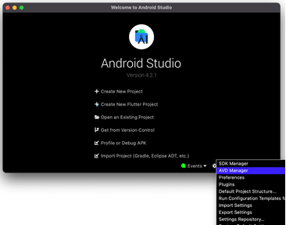

Or, if you have a project open in Android Studio, you can click the AVD Manager button in the toolbar at the top.

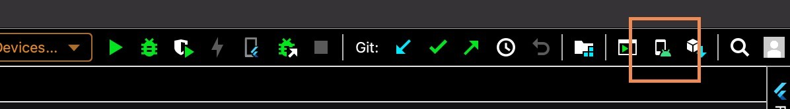

These lists show all the available emulators created.

1. Select the drop-down picklist at the end of your favorite emulator, displaying the options to duplicate the emulator, wipe data, etc.

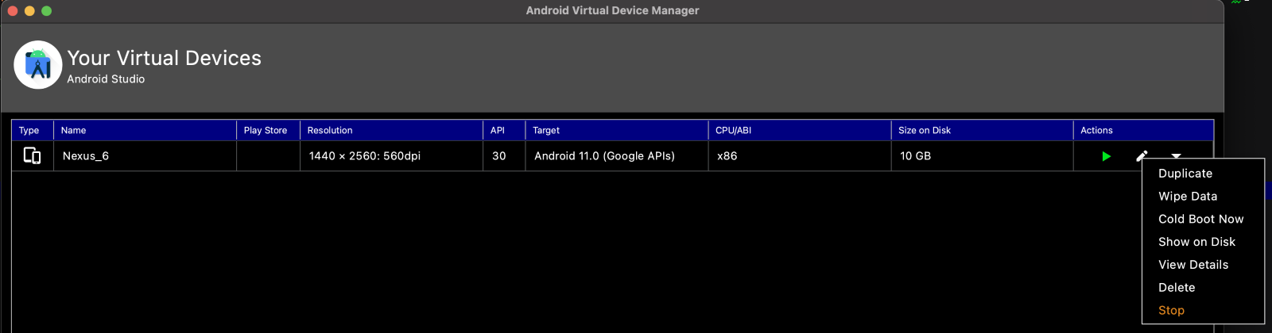

1. Select "Wipe Data," which will completely remove the application from the emulator and the related data. To perform this action, your emulator must not be running. Close it if it is running.

5. Select "Cold Boot Now" to restart the emulator.

## 7.3 Unable to launch Emulator from Editor

If an editor like Visual Studio Code is being used to write the code, then it is possible that the emulator may fail to open when you start running or debugging the main .dart file. In such cases, the emulator opens from the command line interface. Here are the steps on how to do it.

1. Open command prompt or the terminal App (Terminal is also available in the editor itself)
2. Run flutter emulators to list all the emulators in the AVD manager.

3. Run flutter emulators --launch <your favorite emulator id from the list>. Copy the emulator id and paste after "--launch."

## 7.4 Slow Running the App (Stuck at Running Gradle task 'assembleDebug')

It is one of the common issues all users may face, regardless of the editor or operating system. When Flutter tries to start the app in the emulator, the debug console may show "Running Gradle task 'assembleDebug'" for a long time. It happens when Flutter is trying to build the apk file and has many dependencies in the cache. Therefore, cleaning the Gradle will improve this. As the application restarted, it will reimport the required dependencies only and rebuild the apk file.

The following step that cleans the Gradle cache shows below:

1. Open terminal app or the one in the editor.
2. Navigate to the android directory in your project.

3. Run this command: ./gradlew clean.

## 7.5 Dependency Issues

As the application built many times, multiple versions of libraries may get imported. That may make Flutter confused and display errors. In such cases, the Flutter built files must clear, and it should reimport again. Follow the below steps:

1. Open terminal app or the one in the editor
2. Navigate to the project root directory.
3. Run this command: "flutter clean." It will remove all the dependencies.
4. To reimport, the libraries run: flutter pub get. It will reimport the dependencies, and you should not get the errors.

## 7.6 Miscellaneous

If the speech to text function isn't working, check app permissions. The microphone permissions might not turn on, and this issue can go through the phone settings or when the user first opens the app.

If the user's accent is causing trouble with notes being appropriately recorded, use the edit note function to fix them manually.